https://www.etp4hpc.eu/virtual-showcase.html

TWO COMPETITORS HERE OF NOTE
- AGENIUM
- DO IT
Bright computing not a competitor – just interesting slide!

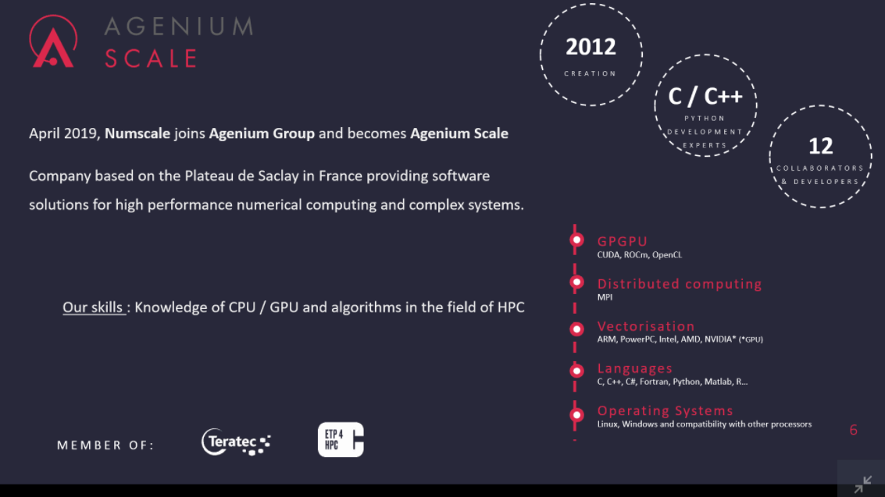

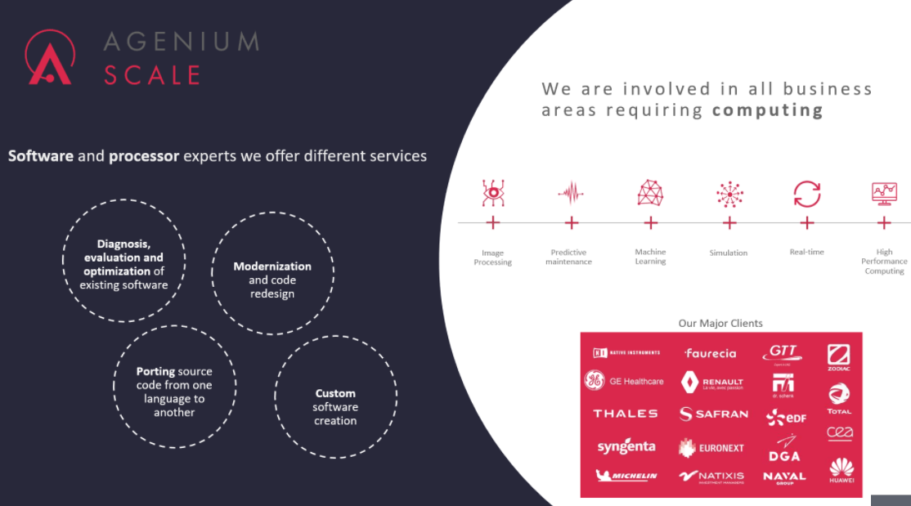

[09:39] John Holden
there's lots of orgs like this in france
​
[09:39] John Holden
justlike in UK we compete with EPCC
​
[09:39] John Holden
M/soft Azure (facepalm) too
​
[09:40] Michael Croucher
Open source CPU/GPU library
​
[09:40] John Holden
in frace many of this are french uni spin offs that then become cos and then bought out,...
​
[09:40] Michael Croucher
It really is too. It's on GitHUB
​
[09:40] John Holden
we could list more of this
​
[09:40] John Holden
great - cheap competitor analysis in 5 mins

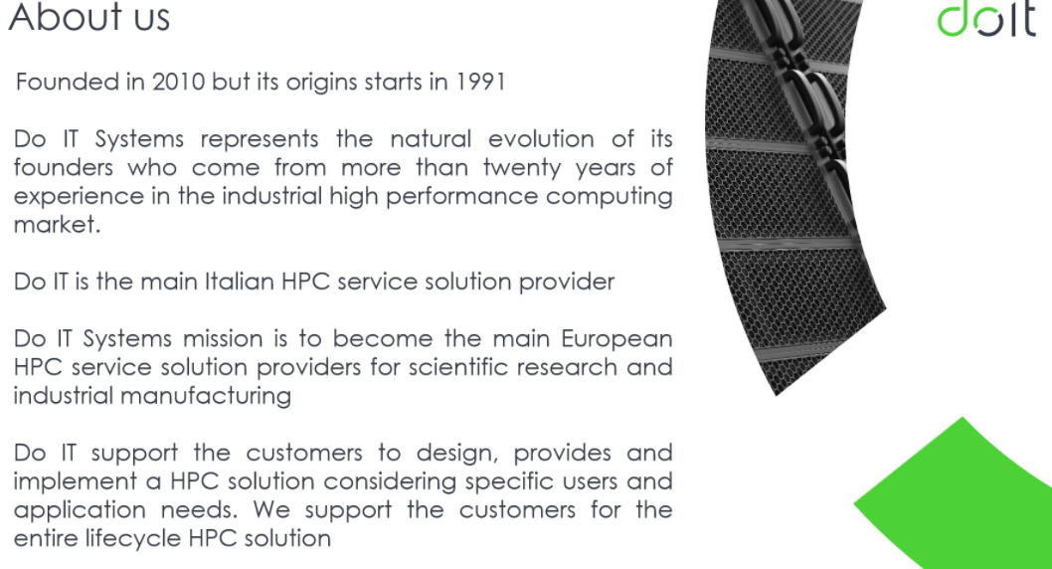

Robert Strano – HQ Turin, main client Ferrari, new co. in France in frew mths

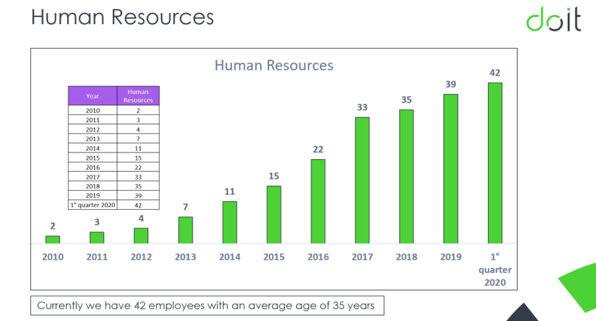

Most staff focussed on HPC (i.e. all tech guys)

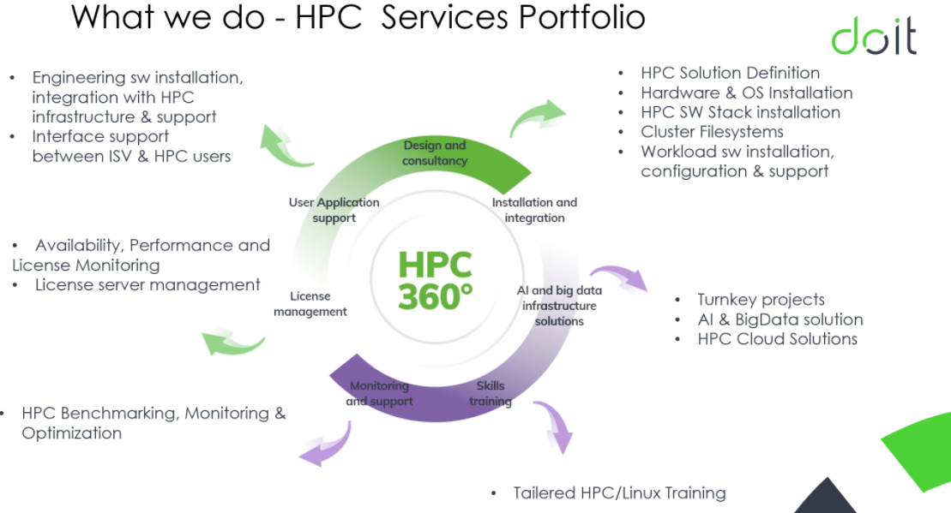
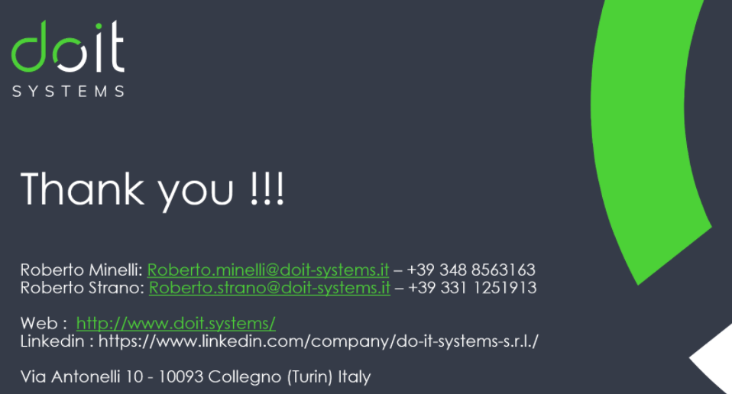

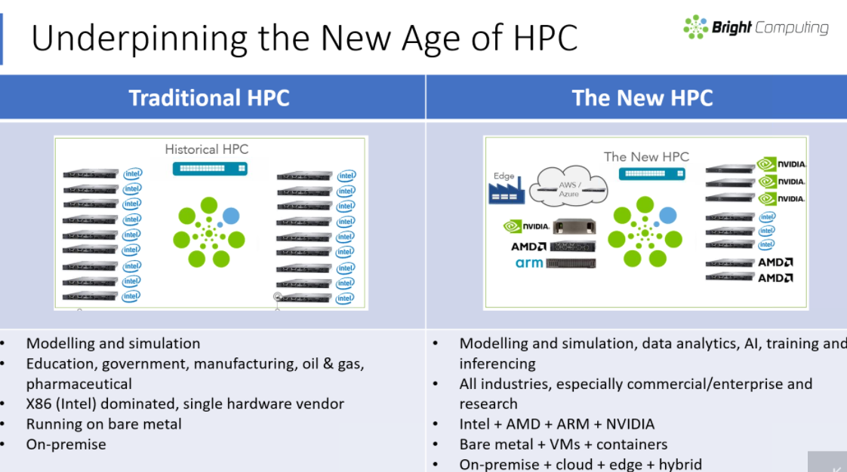

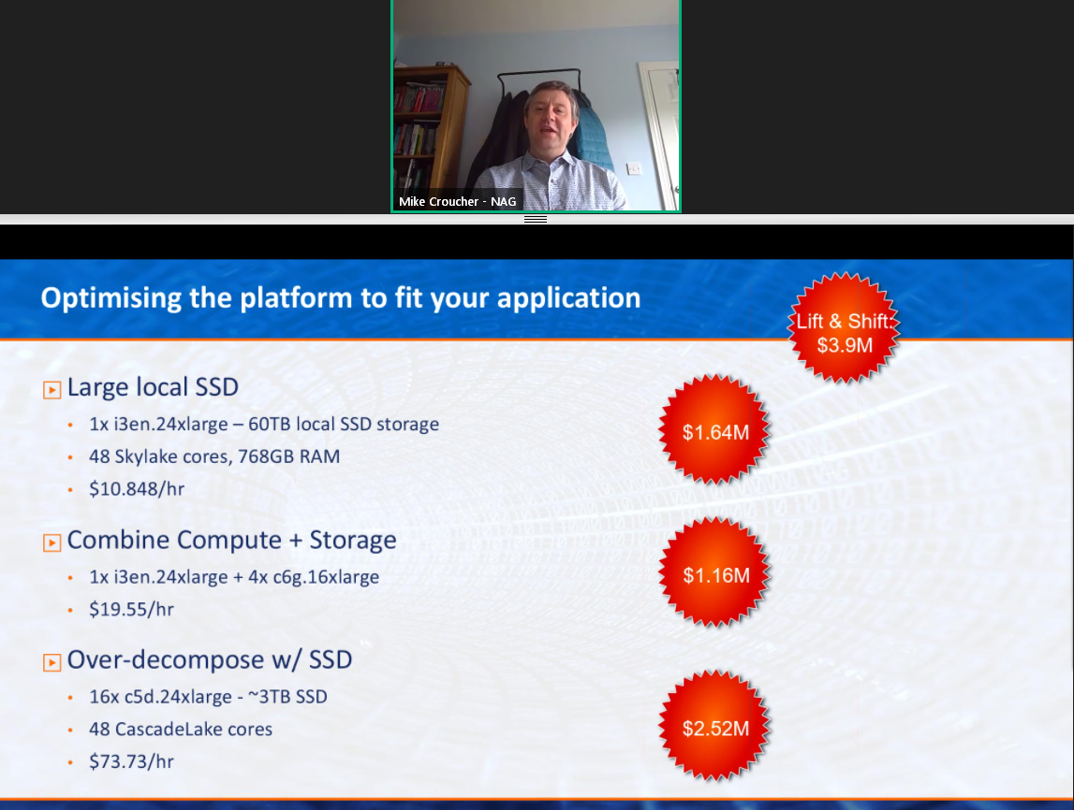



NAG Cloud and ML Product Manager @NAGTalk Mike C @walkingrandomly talks Cloud HPC https://bit.ly/31cFzap in “ETP4HPC Webinar - meet our @ISChpc co-exhibitors” Big thanks to organisers @Etp4H

with @Etp4H as part of @ISChpc

